Vocal Audition Requirements

- Voice students should prepare two contrasting style songs to sing for the audition.
- Each sample should be no longer than 2 minutes. Please submit two separate videos.
- Please use a form of accompaniment track or live accompaniment. If you have difficulty with locating an accompanist, please consider the following resource:
https://www.appcompanist.com/using-appcompanist
Disclaimer: This is an external service and Coastal Alabama Community College has no interest or ownership in this service. It is only suggested for a service for this purpose.
- The Video should include audio and visual. Preferably the Video should be at least from the waist up and in good lighting and sound. Most mobile phones are equipped with good sound properties for recording.
- The video should also include the singing of the two scales on the video.

*Students should sing the D Major Scale and the F Major scale using either Numbers or Solfege Syllables.
Ex.

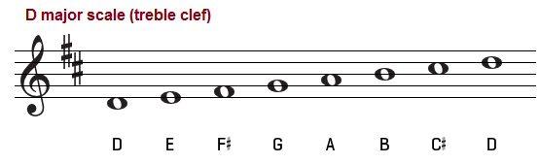

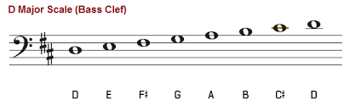

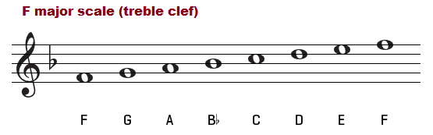

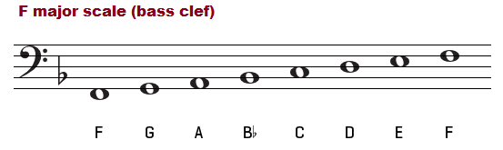

- Please send your videos to the following email address: david.ayers@coastalalabama.edu
- Each Video will be reviewed within one week of receipt and notification will take place at that time.
- Deadline for consideration for Scholarship is April 20, 2020
- Please feel free to contact me via email if you have further questions.

