Instrumental Audition Requirements

- Instrumental students should prepare two contrasting style songs to play for the audition.
- Each sample should be no longer than 2 minutes. Please submit two separate videos.
- The Video should include audio and video. Preferably the Video should be at least from the waist up and in good lighting and sound. Most mobile phones are equipped with good sound properties for recording.
- The video should also include the playing of the two scales below, one octave ascending and descending.

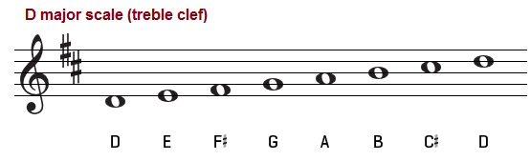

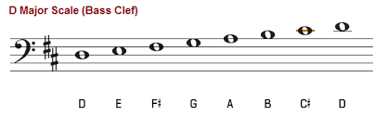

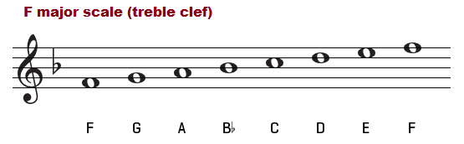

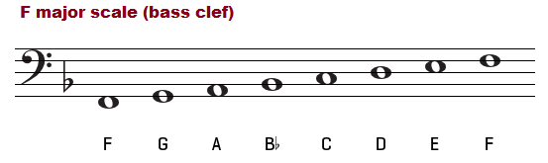

- Please send your videos to the following email address: Rebecca.barry@coastalalabama.edu
- Each Video will be reviewed within one week of receipt and notification will take place at that time.
- Deadline for consideration for Scholarship is April 20, 2020
- Please feel free to contact me via should you have further questions.

